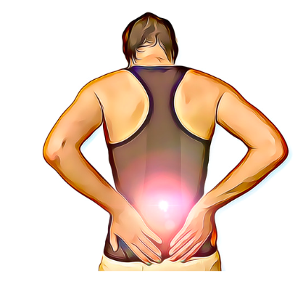
What Causes Joint and Muscle Stiffness?

Joint and muscle stiffness can be felt in any part of the body. While it may be accompanied by pain, this is not always the case and can have many different causes. Feelings of stiffness can be easy to ignore, however, they can be a sign that you are at increased risk of injury or pain. Here are a few reasons why you might be feeling a little bit less flexible.
Muscle Weakness
Muscle stiffness can be a sign that strength is missing. Our body will prioritise stability over flexibility if our muscles don't have the ability to provide both. This means that your muscles will be a bit tighter and stiffer to compensate for any weakness. If you are feeling a little tight and sore, your physiotherapist can help to identify any muscles that maybe need strength targeting to help with feelings of tightness.
Delayed Onset Muscle Soreness (DOMS)
Many of us are familiar with post-exercise pain and stiffness. This is a somewhat protective mechanism to help you recover from a bout of increased exercise. This kind of stiffness will be present in muscles that have been used recently and usually lasts for just a day or two. This kind of stiffness usually goes away on its own, although it can be quite uncomfortable, this is usually nothing to be too concerned with. Your physiotherapists can help you with tips to avoid DOMS in your regular workouts.
Lack of movement
Along with muscle weakness, inactivity can lead to joint stiffness. Joints need to move through their full range regularly to maintain their flexibility, as anyone who has kept their joints still in a cast will know. Lack of movement can lead to a reduction of blood flow and nutrients also impacting joint health. Your physiotherapists can help you to identify any joints that are not moving well and advise you on how to restore joint flexibility. Activities such as Pilates aim to help you move all of your joints through their full range safely and maintain flexibility.
Arthritis
Stiffness is the hallmark of arthritis, often noticeable as increased stiffness on waking that progresses gradually over time. Pain and stiffness caused by arthritis can often be helped by a targeted muscle strengthening program to help support the joints.
Speak to your physio about any tightness or inflexibility and see how they can help you feel your best.

