Roasted Dates With Almond & Ricotta

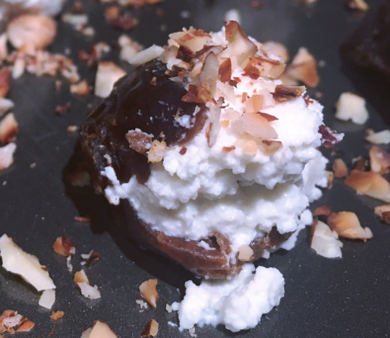
Ingredients
½ cup of Ricotta Cheese
4 Tbsp. of Almond Nuts, crushed
20 Medjool Dates
1 Tbsp. Extra Virgin Olive Oil
1 Tbsp. Balsamic Vinegar Glaze
- Sea Salt to taste
- Preheat an oven to 180º Celsius. Bring a medium-sized frying pan to medium heat and add crushed almonds.
- Stir almonds frequently, until warm and toasted, removing them from heat as they begin to brown. In a small bowl, mix the ricotta cheese and half of the toasted almonds.
- Use a small knife to carefully remove any seeds from the dates, making space for the ricotta mixture. Spoon ¼ teaspoon of the ricotta mixture into each date and place them, evenly spaced, on a foil-lined baking sheet and drizzle with olive oil. Sprinkle dates with remaining almonds and sea salt.
- Roast dates for 15-20 minutes until the ricotta is melted.

Remove from oven and immediately drizzle balsamic glaze.

