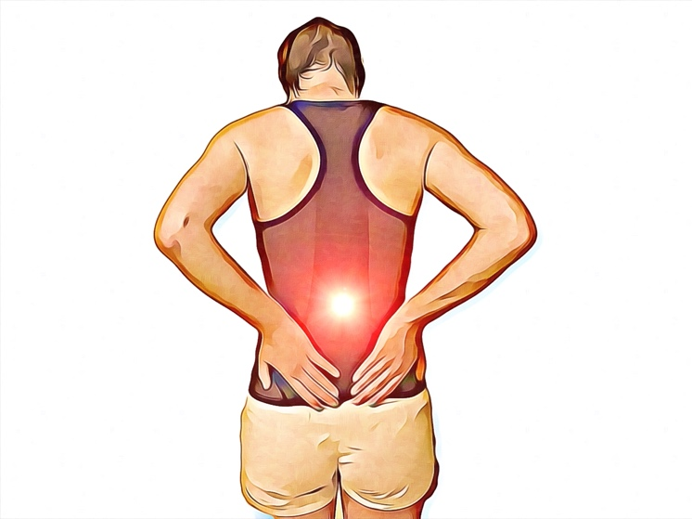
Focus: Can Stress Affect My Pain?

A common fear for patients when discussing pain is the idea that their symptoms are 'all in their head' or that they won't be believed either by friends, family, therapists or workplace. This fear can be worse when there appears to be no obvious cause for their pain or it has been present for a long time.
What is pain?
Many of the models used in the past to explain pain lead us to believe that the intensity of pain will always be proportional to the severity of an injury. The experience of pain is always real and usually distressing. However, pain is a warning system used by our nervous system to alert us to danger, not a direct indicator of damage done. This is a subtle, yet important distinction meaning that the experience of pain can be influenced by many different factors and not exclusively tissue damage.
How can stress impact pain?
Part of the role of your nervous system is to sort through a huge amount of sensory input and interpret it in a meaningful way. When pain is considered to be a serious threat to the body, the intensity of the pain will be worse.
This can happen in many situations, for example:
-The source of the pain is not well understood, leading to fear that the pain might be something very serious.
-The nervous system is in a state of hyper-arousal, such as when you are stressed or tired.
-The pain or injury could have a significant impact on your quality of life, career, relationships or hobbies.
-The injury occurred through a traumatic event such as a car accident.
What does this mean for my treatment?
Along with all our more traditional treatments, we also know that stress reduction strategies, mindfulness and addressing any emotional trauma associated with pain can all help to aid recovery and improve quality of life. Your physiotherapist is a great person to speak to about pain management strategies so you can get the most out of your life while dealing with long-term pain.
None of the information in this article is a replacement for proper medical advice. Always see a medical professional for advice on your individual injury.

