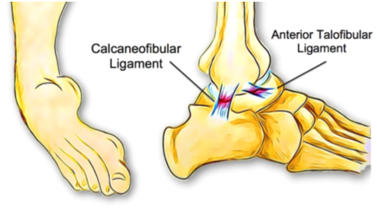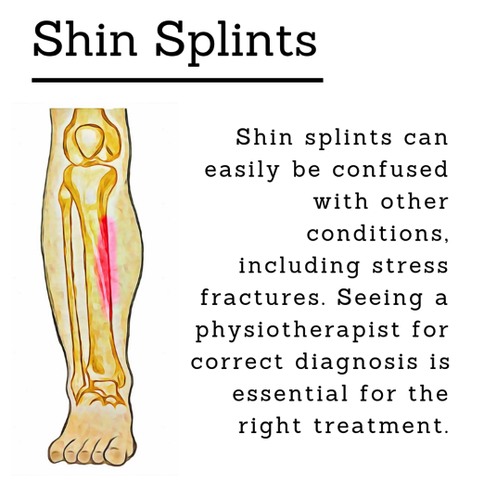k

**What Is Chronic Ankle Instability?**

**Brain Teaser**

OCTOBER 2019

This means that the ankle is more likely to be injured again, creating a vicious cycle leading to further instability.

**How can physiotherapy help?**

Physiotherapy treatment for chronic ankle instability focuses on improving strength, control and balance with a variety of techniques. This approach can significantly improve ankle stability and reduce the risk of future sprains. Physiotherapists can help patients to regain confidence and get back to their best performance.

In some cases, orthotic braces for support can be used. However, this can lead to dependence and further loss of strength and control if used unnecessarily.

In cases of extreme ligament laxity or if physiotherapy fails, surgery to repair the damaged ligaments is considered. This is usually combined with a full physiotherapy rehabilitation program for greatest success.

**If you don’t feel 100% confident with your ankle, come and have a chat with one of our physiotherapists to see if we can help improve your ankle stability.**

1. Unscramble the following common body parts.

ekanl wbleo

mra edah

ofto ekne

dhna abkc

kcee pcekena

Chronic ankle instability, as the name implies, is a chronic condition of instability affecting the ankle and it’s surrounding structures. It usually develops after a severe ankle sprain. However, some people are born with less stable ankles; these individuals are generally extra flexible throughout their bodies. Approximately 20% of ankle sprains lead to chronic ankle instability due to the resulting changes in ligament support, strength, postural control, muscle reaction time and sensation.

**What are the symptoms?**

As well as being more susceptible to ankle sprains, people with chronic ankle instability may notice they are extra cautious during high-intensity activities, if running on uneven surfaces or when changing directions quickly. They may experience a sense of weakness or frequent ‘giving way’ when weight-bearing.

**What are the causes?**

The primary causes of this condition are ligament laxity, decreased muscle strength of the muscles surrounding the ankle and reduced proprioception.

Following an ankle sprain, ligaments can be stretched and slightly weaker; in severe cases, they have torn altogether, leaving the ankle structurally weaker. Without full rehabilitation, the surrounding muscles also become weaker, and studies have shown that balance and sensation of the ankle can also be reduced.

**LIFE HACK**

Follow the 20-20-20 rule to reduce eye strain and headaches.

Look at something 20ft (6m) away for 20 seconds every 20 minutes.

**PHYSIO DIRECT**

**PHYSIO DIRECT NEWSLETTER** FOR APPOINTMENTS **CALL 0800 55 55 123**

NUGGET POINT Send your photos to reception@physiodirectnz.com

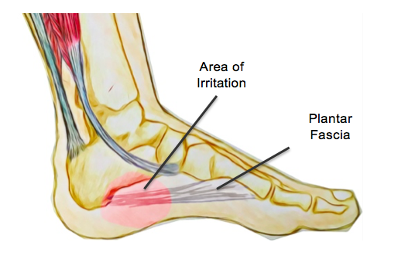

**Beetroot & Haloumi Couscous Salad**

***Ingredients***

*5 Medium sized beetroots*

*1/2 small Red Onion, diced*

*2 cloves of Garlic, diced*

*2 cups Vegetable Stock*

*2 cups Israeli Couscous*

*100g Haloumi Cheese*

*5 Tbsp. Olive Oil*

*Salt and Pepper*

*2-3 fresh Mint leaves*

***Dressing:***

*Finely grated zest of one lemon*

*2 Tbsp. Lemon Juice*

*1. Tbsp. Olive Oil*

*½ Tbsp. Paprika*

1. Heat olive oil in a large pot on medium heat and add diced onion, garlic, salt and pepper. Peel and chop beetroot into small squares and add to pan. Cook on medium heat, stirring frequently until beetroot begins to soften.
2. Add vegetable stock to the pan and bring to boil. Add couscous to boiling mixture, cover and cook for 20 minutes, stirring occasionally. Once couscous is cooked all the way through, remove from heat, strain any excess liquid and allow to cool.
3. Heat a separate pan to medium and add 1 Tbsp. of olive oil. Cut haloumi into slices and cook for 2-3 minutes on each side until brown and crispy.
4. Mix dressing ingredients together and stir gently through couscous. Serve and add haloumi.

**Garnish with mint and serve.**

**Answers**: 1. Ankle, Elbow, Arm, Head, Foot, Knee, Hand, Back, Neck, Kneecap

# **Plantar Fasciitis**

**What is it?**

Plantar fasciitis is a common condition of the foot and heel affecting both athletes and members of the general public. The plantar fascia is a fibrous band of tissue that attaches to the base of the heel and supports the muscles and arch on the base of the foot. When the plantar fascia becomes chronically irritated, it is referred to as plantar fasciitis.

**What are the symptoms?**

Plantar fasciitis is characterised by pain at the base of the heel. The pain is usually noticed upon waking when people take their first steps of the day. The pain usually settles down after walking around, yet may reappear after sitting for a while and getting up again. The pain can usually be reproduced when the inside of the heel is pressed, and the calf muscles might be noticeably less flexible.

Plantar fasciitis can usually be diagnosed with a physical assessment by a physiotherapist. Left untreated, plantar fasciitis can lead to chronic heel pain, which can have a significant

impact on quality of life, interfering with

day to day activities.

**What are the causes?**

The plantar fascia supports the arches in the foot during weight-bearing and acts as a shock absorber. Small tears can appear in the fascia when it is exposed to excess tension and stress over time. While the exact cause is unknown, there are several risk factors that can increase the risk of this condition developing.

These include obesity, excessive foot pronation, inadequate shoe support, prolonged standing and excessive running. It has previously been thought that plantar fasciitis is linked to or caused by heel spurs. However, this has been shown to be untrue, and many people have heel spurs without any symptoms.

**How can physiotherapy help?**

The goal of physiotherapy is to reduce symptoms and support the fascia to reduce and repair any tissue damage. This is done through short term pain reduction strategies such as ice application, rest, activity modification and gentle stretches.

To help reduce the tension on the fascia, lower leg strengthening and

implemented along with orthotics, night splinting and in some cases, corticosteroid injections. A night splint can be helpful in keeping the calf muscles lengthened as they often rest in a shortened position overnight.

Other treatment options include extracorporeal shockwave therapy and endoscopic plantar release. However, these interventions will also be coupled with physiotherapy treatment for best results. Patients who are not responding to physiotherapy and other conservative management are candidates for surgical release of the plantar fascia.

**None of the information in this newsletter is a replacement for proper medical advice. Always see a medical professional for advice on your individual injury.**

Matamata Putaruru Te Aroha Rotorua

Murupara Ngongotaha

Taupo Taumarunui

Oxford Ohakune

Belfast Westport

Greymouth

P: 0800 55 55 123

For locations go to www.physiodirectnz.com

Physio Direct

Rural physio at YOUR doorstep