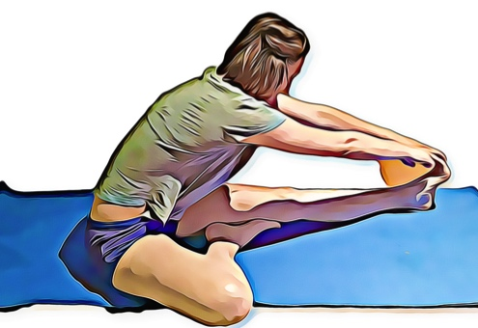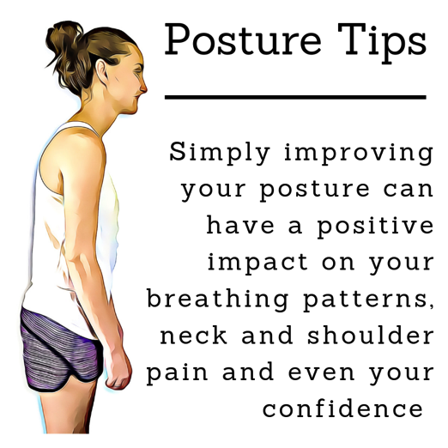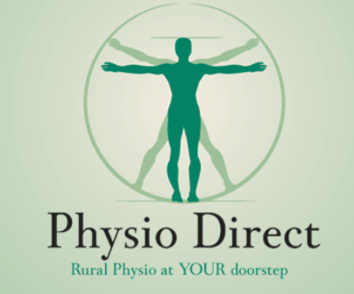k

**Move More, Sit Less – 5 Tips From Your Physio**

**Brain Teasers**

SEPTEMBER 2019

**3. Park further away**

This is an oldie, but a goodie. If you can’t ride or walk to your daily destinations, try parking further away and using the opportunity to walk. Taking the stairs instead of the elevator and getting up and walking while taking phone calls are also great ways to increase your daily movement.

**4. Have a kettle boiling exercise routine.**

The time spent waiting for the kettle to boil can feel like an eternity. Use this time to undertake a mini exercise routine. Try fitting in two sets of five squats, five lunges; five heel nurses or try to balance on each leg for two minutes.

**5. Stretch before bed**

Gentle stretches before bed are a great way to relax and keep your joints mobile. Create a routine and make it part of our nightly ritual for better sleep and a healthier body.

**Our physiotherapists are happy to help you find strategies to create more movement throughout the day. Come and have a chat with us to see what might work for you.**

1. Name two countries that have six letters but only one syllable.

2. What are the world’s largest country, ocean and longest river?

3. What percentage of the world’s population lives in the northern hemisphere?

**More movement in your day can improve mental, physical health and even workplace productivity. Physiotherapists know that one of the most significant contributors to pain and injury is simply lack of physical activity. Getting more movement in your day doesn’t need to be about high-intensity exercise, all movement can be beneficial. Here are a few tips to help increase the amount of motion in your day.**

**1. Try the Pomodoro Technique at work or when studying**

The Pomodoro Technique, developed in the late 1980s, recommends breaking work into intervals, usually 25 minutes at a time interrupted by short rests. Studies’ have shown that by creating small time limits, you can focus more intently and the breaks can be useful motivators.

Use these intervals as prompts for a short walk, some squats or stretches. Not only will you have made your day more productive, but you will also have added some movement to your day.

**2. Challenge a friend to match your steps**

A little healthy competition is a great way to keep you motivated to move more. You can set daily, weekly and monthly targets and compare progress to keep you on track.

You can use an app like ‘Habitica’ to help track and create movement habits in a game format, making reaching your goals a little more fun.

**LIFE HACK**

Having trouble buying a present for someone?

Tell them you’ve brought them something amazing and make them guess what it is. Their guesses will give you inspiration.

**PHYSIO DIRECT**

**PHYSIO DIRECT NEWSLETTER** FOR APPOINTMENTS **CALL 0800 55 55 123**

CARDRONA Send your photos to reception@physiodirectnz.com

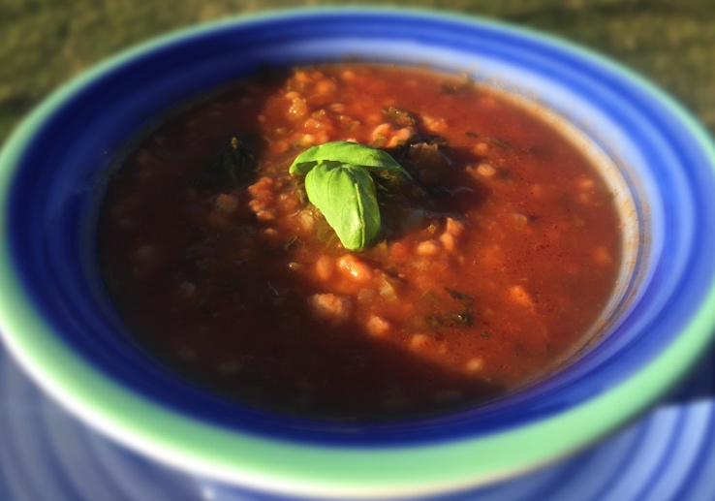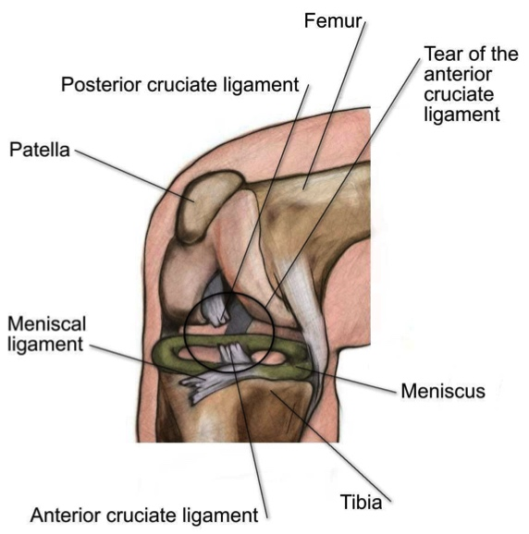

**Tomato, Basil and Barley Soup**

***Ingredients:***

*2 tins diced Tomatoes*

*1 small Red Onion, diced*

*2 small carrots, diced*

*1 handful Fresh Basil*

*2 cloves of Garlic*

*2 cloves of Star Anise*

*2 cups Vegetable Stock*

*2 cups Water*

*1/2 cup Pearl Barley*

*50g Parmesan Cheese*

*2 Tbsp. Olive Oil*

*Salt and Pepper*

1. Heat olive oil in a large pot on medium heat. Add diced onion, carrots, basil and garlic and cook until onions begin to soften. Soak barley in a separate pot of cold water for 10 minutes and set aside.
2. Add tomatoes, vegetable stock, water and star anise to the pot and bring to boil, stirring occasionally.
3. Drain barley and add to the soup mix. Reduce heat and simmer for about 30-40 minutes, add salt and pepper to taste. Remove from heat and serve while hot.

**Garnish with basil and Parmesan cheese**

**Answers**: 1. Greece and France 2. Russia, the Pacific Ocean and The Nile River 3. 90% of the world’s population lives in the northern hemisphere

# **ACL Tears**

Focus On…

**What is an ACL tear and how does it occur?**

The ACL, or anterior cruciate ligament, is a strong piece of connective tissue, which attaches the thigh bone (femur) to your leg bone (tibia). The ACL provides stability to the knee joint as it prevents the tibia from sliding forward relative to the femur.

ACL tears are a common sporting injury; however, can also occur from everyday activities. The most typical mechanisms of injury are landing awkwardly from a jump, twisting the knee, or suddenly stopping while running. The ACL may also be injured during knee hyperextension, or when hit from the outside. Often, other tissues surrounding the knee are also damaged, including the medial collateral ligament, meniscus, joint cartilage, and bone surfaces. The ligament can be stretched, partially damaged or completely torn.

**What are the signs and symptoms?**

Many people report hearing a “pop” in the knee along with immediate pain and swelling. Decreased range of movement of the knee is common, and the injured knee is typically unable to take full weight when standing or walking. The knee may also feel unstable, with a sensation of

“giving way”. Poor balance and coordination may also be experienced. Smaller tears of the ligament may have only mild symptoms, however, more severe tears will have more significant pain, swelling and instability.

**Is surgery necessary?**

Traditionally, surgery was thought to be necessary for all full-thickness ACL tears. A series of recent studies have shown, however, that outcomes are often the same for people who chose surgery and those who don’t, both in terms of recovery and future risk of osteoarthritis. Individual circumstances will impact this decision; elite athletes and patients with additional meniscal tears often do best with surgery.  Generally speaking, however, with time and full rehabilitation, many people can return to their previous levels of activity without surgery.

**How can physiotherapy help?**

For both surgical and non-surgical recovery from ACL tears, physiotherapy rehabilitation is essential for a full recovery. Your physiotherapist will assist you with improving your knee’s range of movement, lower limb strength, balance, stability and coordination. You will re-learn the tasks of walking, using stairs, and negotiating obstacles with retraining of your balance and control.

Early in rehabilitation, the RICE protocol (rest, ice, compress, elevation) is used in conjunction with static resistance type exercises to improve muscle contraction in the leg and increase blood flow in the area.

Throughout your rehabilitation program, you will progress through a variety of strength and mobility exercises targeted towards your individual needs, with goals of returning to your favourite sport or hobby as soon and as safely as possible.

**None of the information in this newsletter is a replacement for proper medical advice. Always see a medical professional for advice on your individual injury.**

Matamata Putaruru Te Aroha Rotorua

Murupara Ngongotaha

Taupo Taumarunui

Oxford Ohakune

Belfast Westport

Greymouth

P: 0800 55 55 123

For locations go to www.physiodirectnz.com

Physio Direct

Rural physio at YOUR doorstep